Use Case Diagram Level : 0

ID No : 01

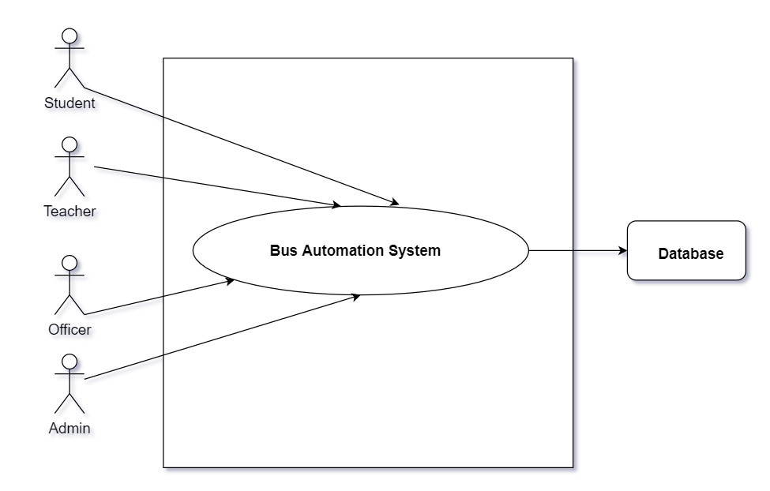

Description: The use case “Bus Automation System ” at level 0 shows the top-most view of the project and all the actors, namely:

Primary Actor :

1. Students
2. Teachers
3. Officers
4. Admin

Secondary Actor :

1. Database

Use Case Diagram Level : 1

Name : Sub-system of Bus Automation System

ID No : 02

Description: Bus Automation System is divided into 2 main subsystems: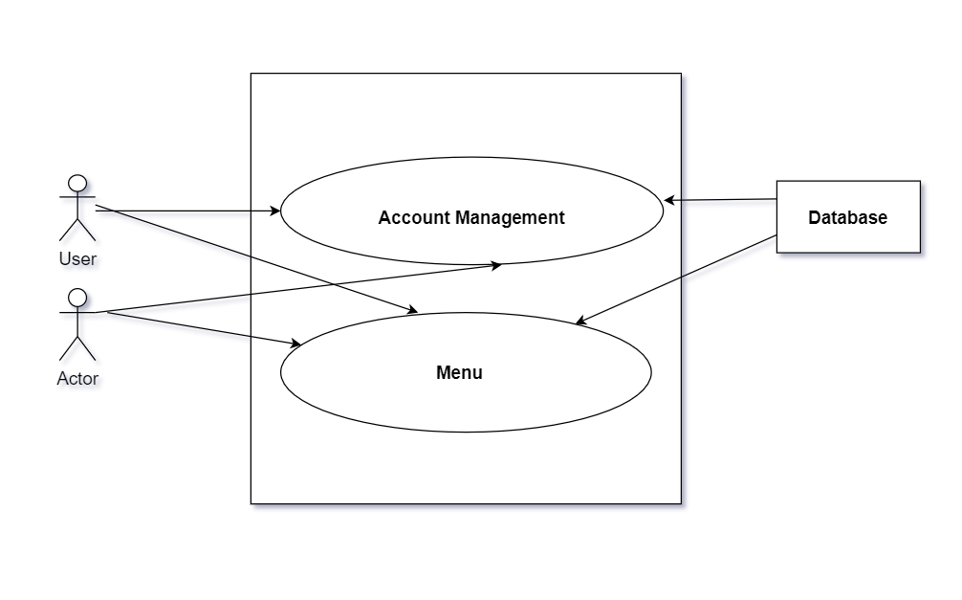

1. **Account Management :**

2.**Menu**:

Use Case Diagram Level : 1.1

Name : Account Management

ID No : 03

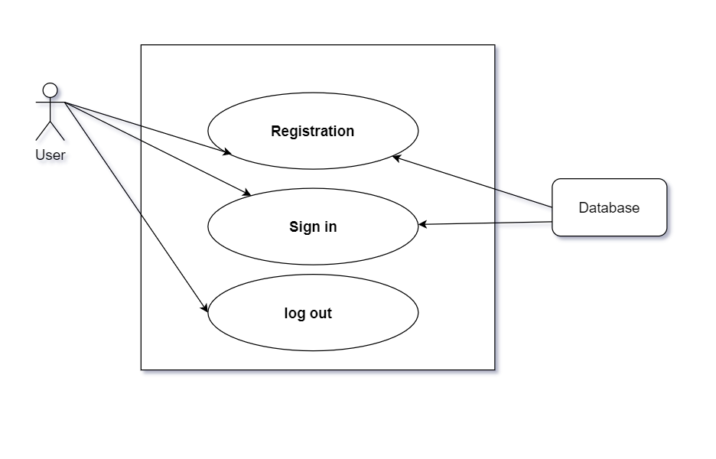

Description: Account Management System is divided into 3 main subsystems:

1. **Registration :**

2. **Sign in** :

3. **Log out :**

Use Case Diagram Level : 1.2

Name : Menu

ID No : 04

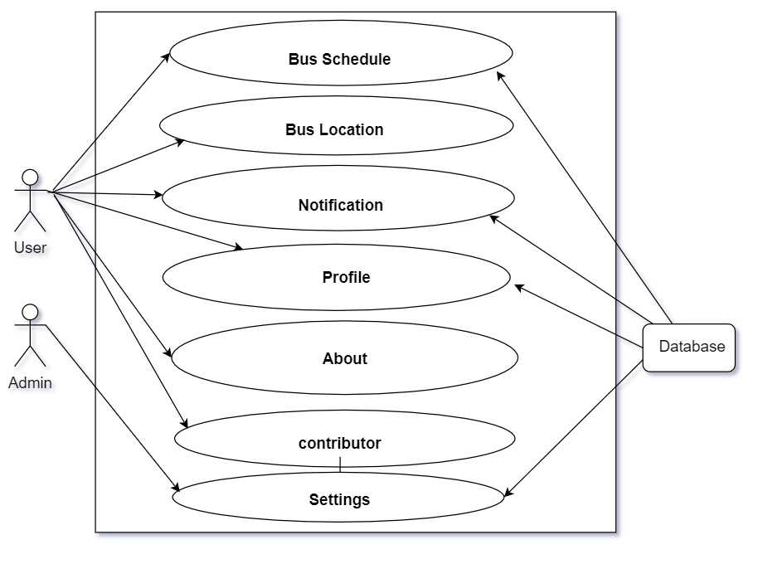

Description: Menu System is divided into 7 main subsystems:

1.

2.

3.

4.

5.

6.

7.

Use Case Diagram Level : 1.2.3

Name : Notification

ID No : 05

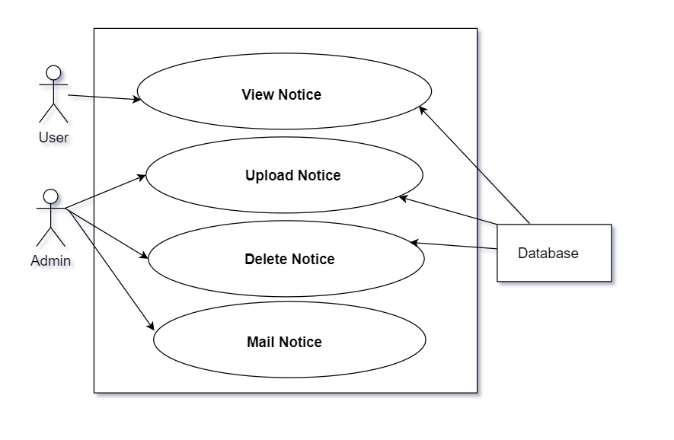

Description: Notification sub-system is divided into 4 main subsystems:

1. View Notice :
2. Upload Notice :
3. Delete Notice :
4. Mail Notice :

Use Case Diagram Level : 1.2.4

Name : Profile

ID No : 06

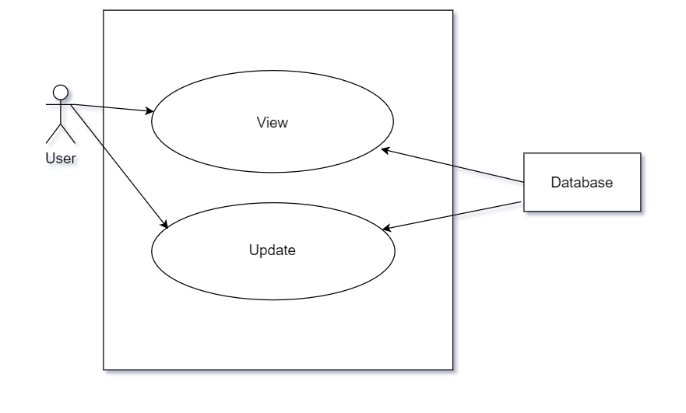

Description: Profile sub-system is divided into 2 main subsystems:

1. View :
2. Update :

Use Case Diagram Level : 1.2.7

Name : Settings

ID No : 07

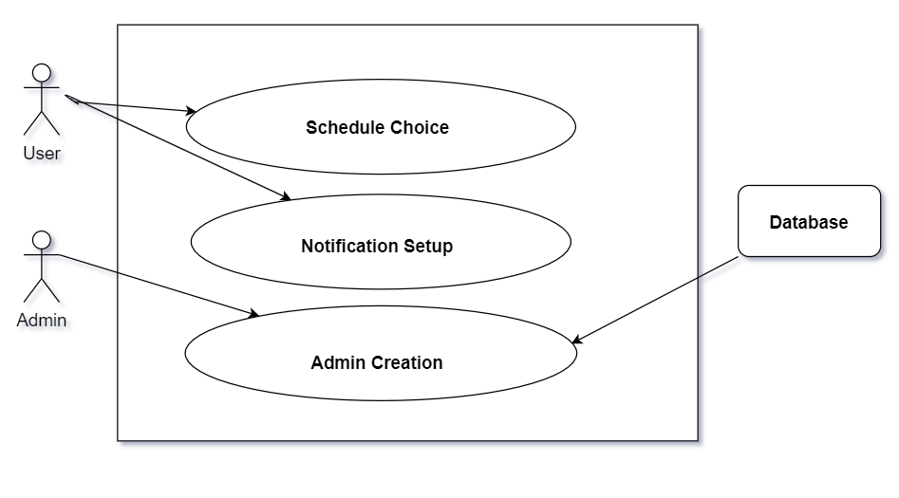

Description: Settings sub-system is divided into 3 main subsystems:

1. Schedule Choice :

2. Notification Setup :

1. Admin Creation

Use Case Diagram Level : 1.2.7.1

Name : Admin Creation

ID No : 08

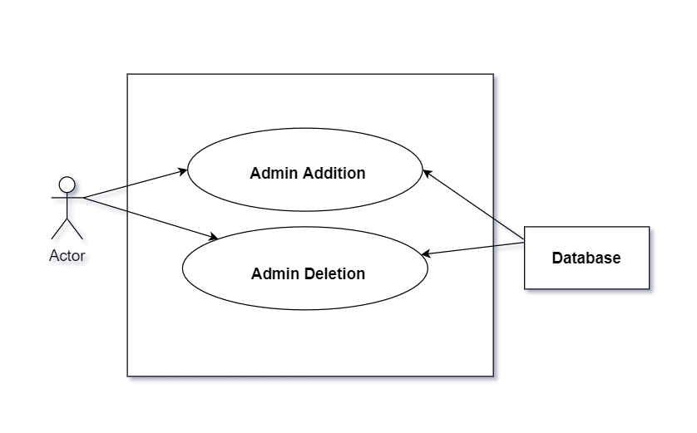

Description: Admin Creation sub-system is divided into 2 main subsystems:

1. Admin Addition :

2. Admin Deletion :